OBJECT ORIENTED PROGRAMMING

Okay everyone, you see those big title up there ? That was the best thing happen on programming world, I mean Like parachute pants and Pac-Man, OOP (object-oriented programming) got its start in the 1980s. But unlike trendy fashions and video game characters, this programming model is still going strong after these many years. And we caught on wrong way, think that this paradigm is so bold and yeah, some of IT professional think it as a challenging phases of programming journey. Well I couldn’t say more, but sometimes irresistibly adorable, in the ‘somewhat’ way.

Enough for the intro, sit tight because we will jump into a hot tea of this topics. Tell me, you got into this discourse because someone here have a big curiosity of what happen on earth after heard that object oriented are so unique and powerfull.

You may be wondering why you even need objects when you could use the top-down approach of traditional structured programming in languages like Visual Basic. Come to grips with OOP, however, and you’ll see that it’s a whole new way of solving problems. The basic concept is that instead of writing a program, you create a class, which is a kind of template containing variables and functions. Objects are self-contained instances of that class, and you can get them to interact in fun and exciting ways.

Let’s get along with this for sure now. If you familiar with this, you might know that OOP have 4 pillars, a strong 4 like fantastic four. Those are, inheritence, polymorphysm, encapsulation and abstraction.

Talk about these 4 pirinciples of OOP, let’s hop into the first pillar.
1. Inheritance.
Think it as a cartoon. Have you guys watched “Avatar: the legend of Korra”? We can take it as an example of inheritance. Korra have parents Tonraq and Senna. Korra inherits from her parents, she have her mother eyes and the skin color’s of her father. So basically, Inheritance is where you have parents , OOP call it Super-Class and child as Sub-Class. It’s like parent’s child relation and guys, yes of course Korra (Sub-class) have her own characteristics that her parents doesn’t.

Below is an example of inheritance
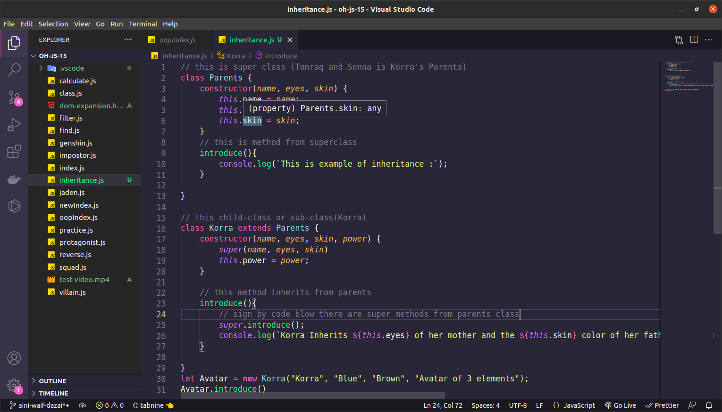
This is where the inheritance technique saves time. As you see in the example, the method and property can be reuse all over again instead of making a new function and coding is light.

2. Polymorphysm
still make an example of Korra. So, Korra as a child class have her own method as we see in the example below

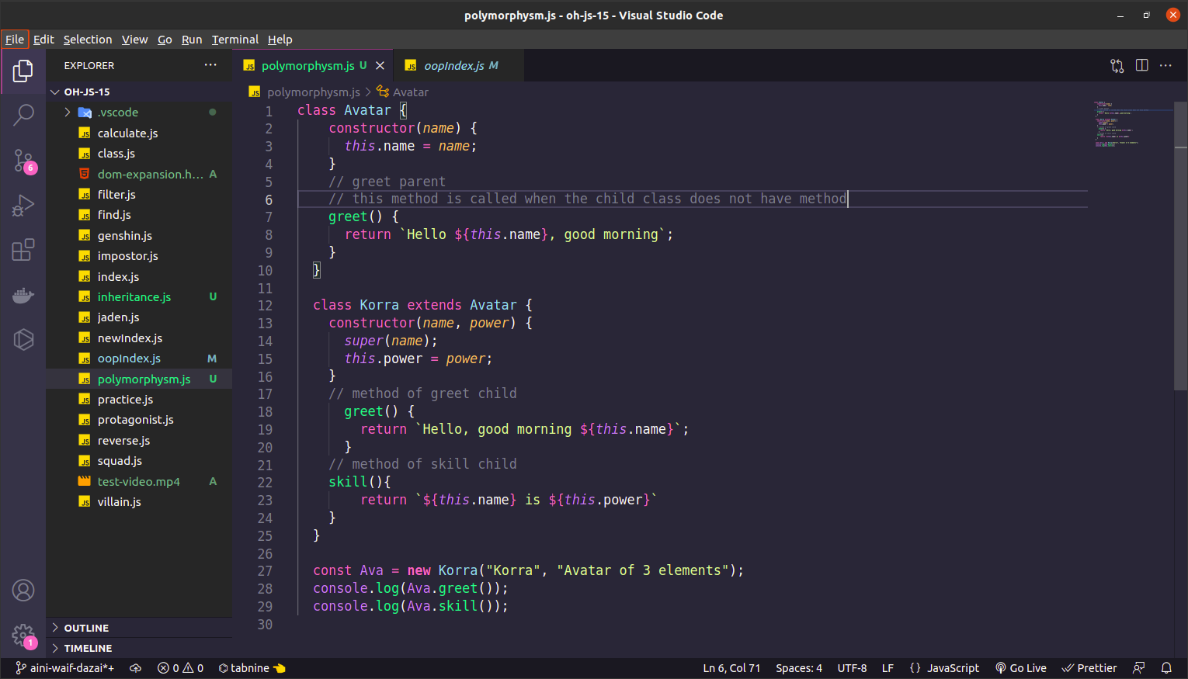
in polymorphysm, when child have own method, the first turn to execute is that method from child class even tho the parent class have it own method. The method of parent class will be execute if the child class doesn’t define method.

3. encapsulation
guys, we hop onto pillar 3 which is encapsulation. Now! Take a deep breath, relax and boom! This is the part when i want to greet y’all. Because encapsulation is the part that i like the most. The speciality of encapsulation is you makesure that no one can duplicate your functionality_your code_.

We take an example, Korra we know have an avatar’s power but only her know how to control her power and no one can modified her power.

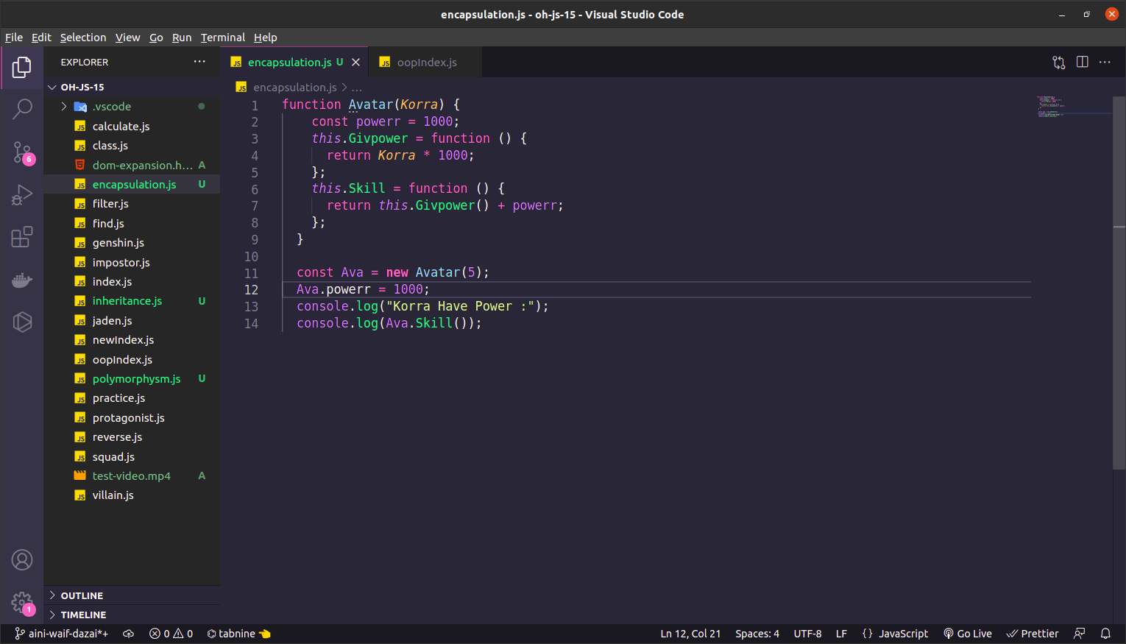
If you see up there, i already make an example, that Korras have a power (by number) and after she gain the power, thats belong to her that nobody can bother it.

4. Abstraction.
Well, this is the last part of the topics today. And hold on, go grab some coffe and yes don’t forget to check all of the example of code from 4 pillars that i already explained.

We can go on the example of Avatar Korra again, so do not grumbling and sit tight. If you know, the avatar have a power of 4 elements and it so powerfull. Korra have that power, we know the name but we dont know how the process of the power it self. We just now the output. And oh I forget to tell y’all that encapsulation and abstraction just announced as a sibling from another parents, lmao. Lets go check the example.

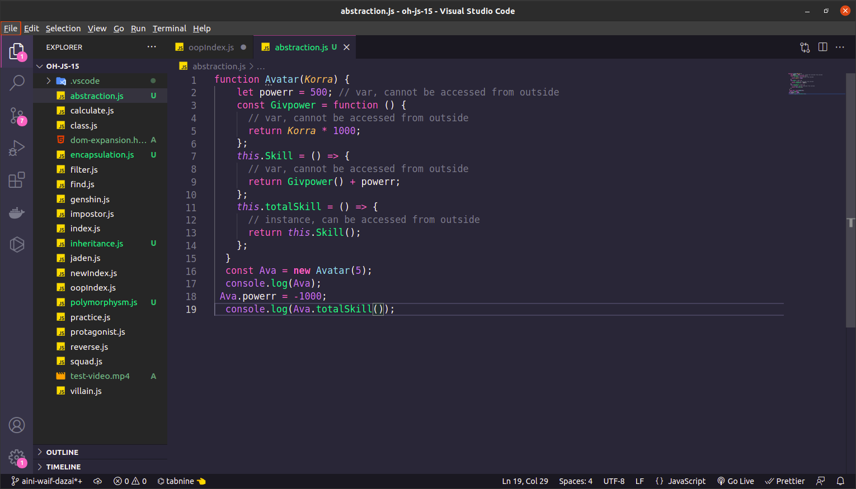
Guys when you try those code up there, you might found that the instance of Skill could not be read, you just discover the output .

